Kevin Metelus

CMSI 402 Homework 2

Problem 5.1, Stephens page 116  
  
What's the difference between a component-based architecture and a service-oriented architecture?

A component based architecture is a collection of loosely coupled components that provide services for each other. A service oriented architecture is similar, but the components even more separated/modular and are implemented as a self-contained/standalone program that runs on its own and provides services for clients.

Problem 5.2, Stephens page 116  
  
Suppose you're building a phone application that lets you play tic-tac-toe against a simple computer opponent. It will display high scores stored on the phone, not in an external database. Which architectures would be most appropriate and why?

A monolithic architecture fits well because tic-tac-toe is a simple game and it does not require much outside of the team and the high scores are stored locally. A data centric architecture would also work for the game to because the possible moves are set and can be pulled from the database as well as the score. The user interface will be event driven and could also make the AI event driven based on the player’s moves. The other architectures provide too much overhead for a simple tic tac toe game.

Problem 5.4, Stephens page 116  
  
Repeat question 3 [after thinking about it; it repeats question 2 for a chess game] assuming the chess program lets two users play against each other over an Internet connection.

Since the AI component has been removed from the picture and players are instead playing other players, several architectures are no longer required. With these changes the application uses monolithic, data-centric, service oriented architectures for implementation.

Problem 5.6, Stephens page 116

What kind of database structure and maintenance should the ClassyDraw application use?

It can store drawings in separate files so the OS can handle file management rather than using a database management system. Programs like Microsoft Word store current changes in a temporary file so that in the event in a crash, the file can be restored from that temporary file. I think ClassyDraw implementing something similar would be to its user’s benefit.

Problem 5.8, Stephens page 116

Draw a state machine diagram to let a program read floating point numbers in scientific notation as in +37 or -12.3e+17 (which means -12.3 x 1017). Allow both E and e for the exponent symbol. [Jeez, is this like Dr. Dorin's DFAs, or what???]

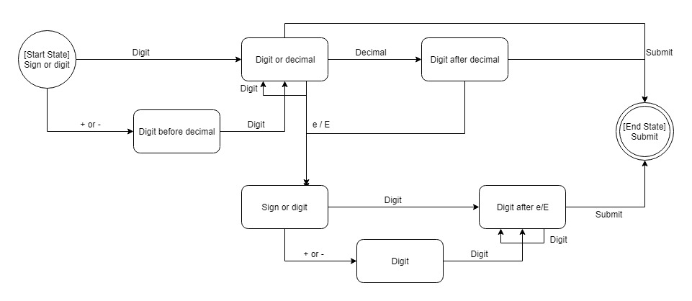

Problem 6.1, Stephens page 138  
  
Consider the ClassyDraw classes Line, Rectangle, Ellipse, Star, and Text. What properties do these classes all share? What properties do they not share? Are there any properties shared by some classes and not others? Where should the shared and nonshared properties be implemented?

These classes all share the property of drawing a line between a couple points. Line, Rectangle, Ellipse, and Star feature a line color property. The shapes (everything except line and text), all have a fill color for the inside of their shapes. The would need to store their scale (width and a height). The text class has special properties because it needs a font type and the string itself to draw. It also has a font color property for styling.

Problem 6.2, Stephens page 138  
  
Draw an inheritance diagram showing the properties you identified for Exercise 1. (Create parent classes as needed, and don't forget the Drawable class at the top.)

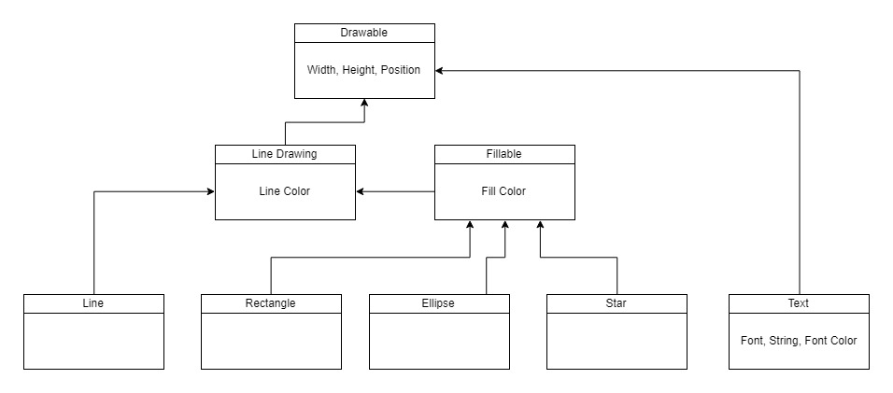

Problem 6.3, Stephens page 139  
  
The following list gives the properties of several business-oriented classes.  
  
Customer — Name, Phone, Address, BillingAddress, CustomerID  
Hourly — Name, Phone, Address, EmployeeID, HourlyRate  
Manager — Name, Phone, Address, EmployeeID, Office, Salary, Boss, Employees  
Salaried — Name, Phone, Address, EmployeeID, Office, Salary, Boss  
Supplier — Name, Phone, Address, Products, SupplierID  
VicePresident — Name, Phone, Address, EmployeeID, Office, Salary, Managers  
Assuming a Supplier is someone who supplies products for your business, draw an inheritance diagram showing the relationships among these classes. (Hint: Add extra classes if necessary.)

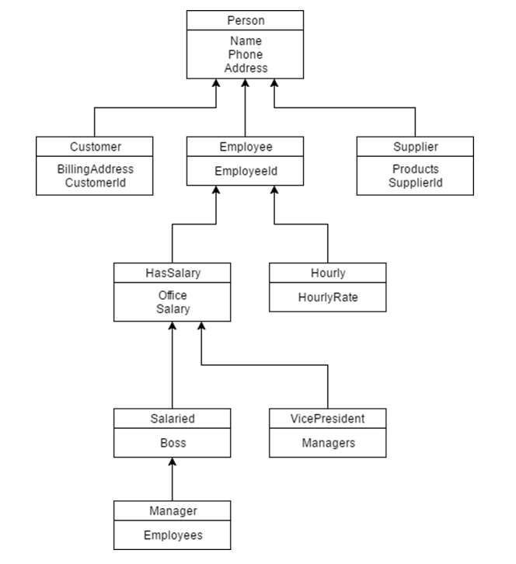

Problem 6.6, Stephens page 139  
  
Suppose your company has many managerial types such as department namager, project manager, and division manager. You also have multiple levels of vice president, some of whom reprt to other manager types. How could you combine the Salaried, Manager, and VicePresident types you used in Exercise 3? Draw the new inheritance hierarchy.

You can move Office,Salary, Boss, and Employees into Salaried and get rid of Manager altogether.

